已翻譯並直接把中文版內容更新至網站
Start translation with:
- Podiatry
(服務) (標題)

SURG
已把中文版內容更新至網站
https://kwh.9u1.net/Services/Surgery.html
Received user comments, at “SURG” folder with folder named “20241107”

DENT
已把中文版內容更新至網站
https://kwh.9u1.net/Services/Dentistry-And-Maxillofacial-Surgery.html
Received user comments, at “Dental” folder with folder named “20241021”

Community Nursing Service (Outreach Service)
有待溝通
https://kwh.9u1.net/Services/Community-Nursing-Service.html
Received user comments, at “Community Nursing Service (Outreach Service)” folder with folder named “241030”

Pain Medicine
已把中文版內容更新至網站
https://kwh.9u1.net/Services/Pain-Medicine.html
Received user comments, at “Pain” folder with folder named “241118”

M&G
已修改
https://kwh.9u1.net/Services/Medicine-And-Geriatrics.html
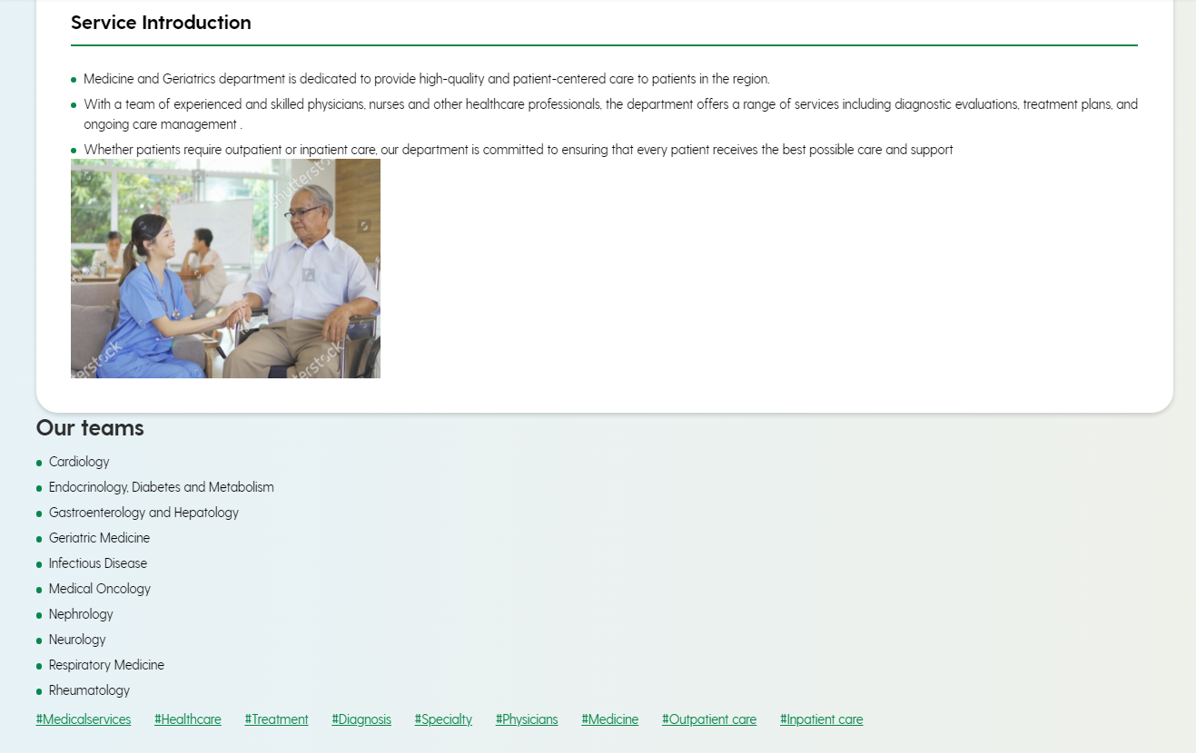

MSS
已換上Location的圖片
https://kwh.9u1.net/Services/Health-Promotion-Centre.html
Location image at “MSS” folder named “241115 Health Promotion Centre”

Anaes&OT
https://kwh.9u1.net/Services/Anaesthesiology-Operating-Theatre-Services.html
已修改
- The banner image would like to have the same effect with A&E one (which is at the center and having some blur part at left and right)
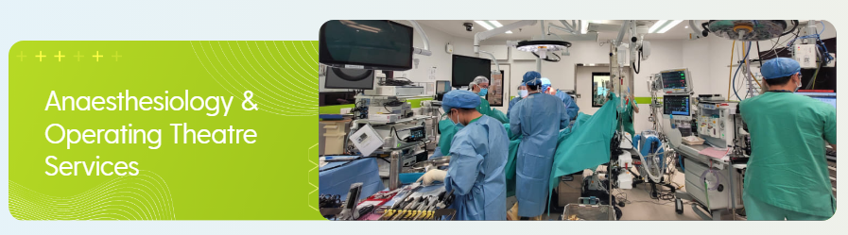
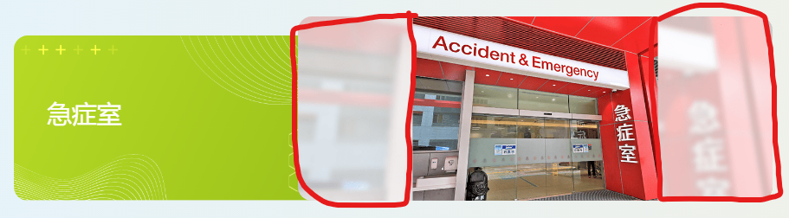
已修改
- follow the photo layout as previous one (remove the grey part)
Previous:
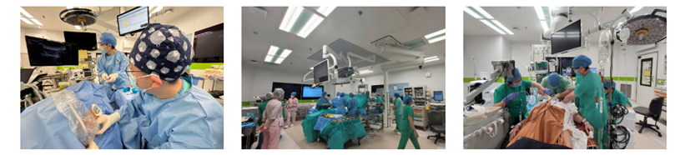
Current:
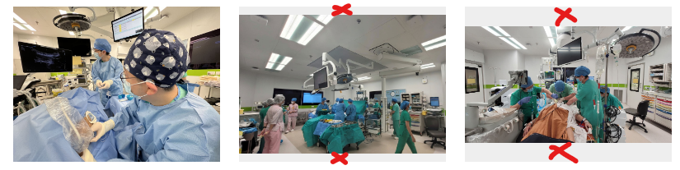

已修改
Anaes&OT (Cont.)
change the display method like the following layout
(Please note the first paragraph was separated as two paragraphs)
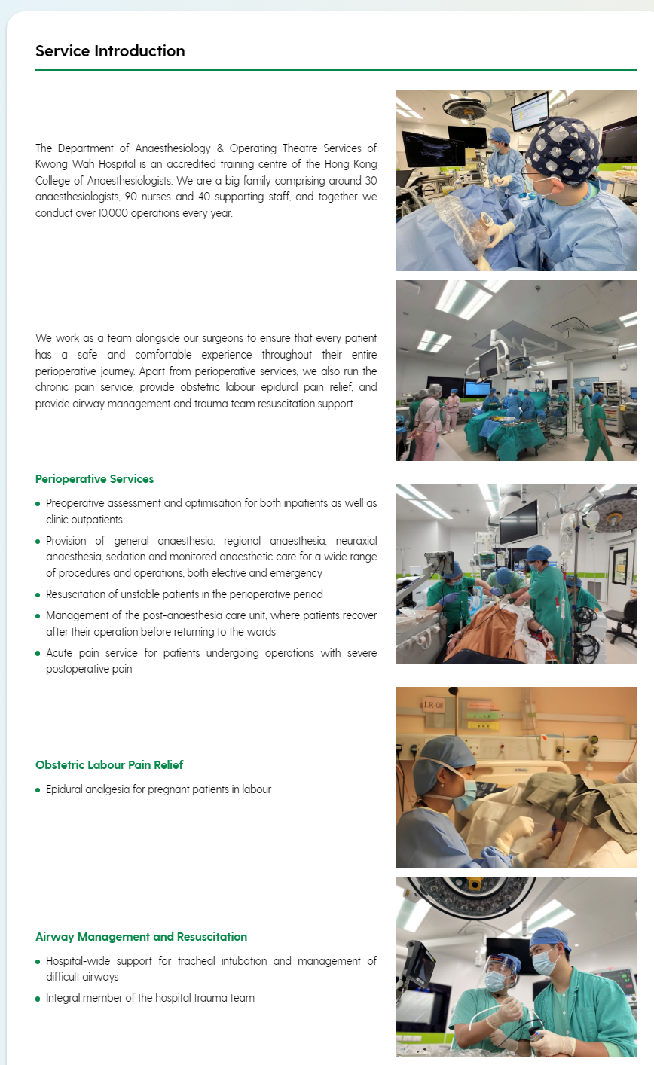

Pathology
已修改
https://kwh.9u1.net/Services/Pathology.html
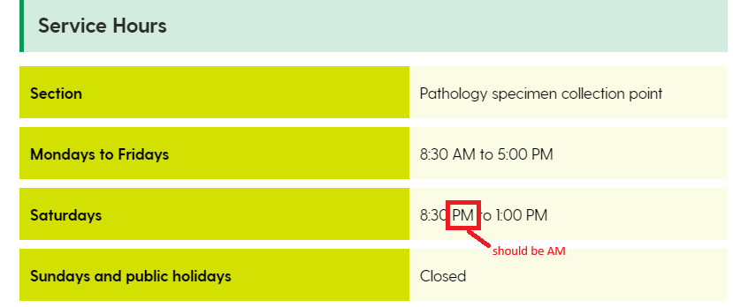

Please also change the Chinese version
星期一至五 | 上午 8:30 至下午 5:00
星期六 | 上午 8:30 至下午 1:00
星期日及公眾假期 | 關閉

“作為九龍中聯網的一部分，我們的服務包括為廣華醫院、聖母醫院及東華三院黃大仙醫院的病人進行化驗檢測，以及管理廣華醫院太平間安寧閣。此外，我們也參與東華三院醫療部發起的計畫。我們也為香港理工大學和東華學院醫學檢驗科學專業的學生提供培訓。”

Ophthalmology
已修改

https://kwh.9u1.net/Services/Ophthalmology.html
Received user’s comment, at “OPT” folder with named as “241115 HKW website 04”

https://kwh.9u1.net/Services/Intensive-Care-Unit.html#shadowBox83
https://drive.google.com/drive/folders/1YTmDXQfjpzE-EH8zygt7obFFDYTfOguC
已修改
需要按照網站語言的切換, 而下載不同語言的文件
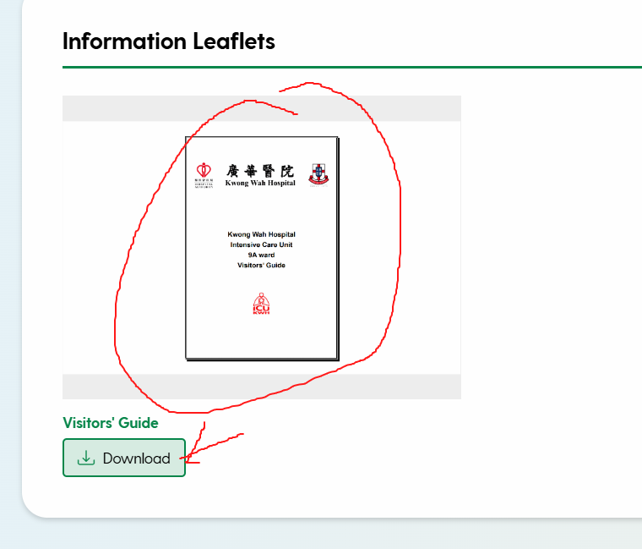

https://kwh.9u1.net/Services/Medicine-And-Geriatrics.html
已修改
更換有水印的圖片

https://kwh.9u1.net/Services/Community-Nursing-Service.html?lang=hk
已修改
輸入中文資料, 及把word檔轉換成PDF及翻譯至簡體版

另外, 在今次的更新中, 以下的頁面亦已把中文版內容更新至網站
Pharmacy
Medical Social Service
Podiatry
Redevelopment Project

